**PROJECT REPORT TEMPLATES**

1. **INTRODUCTION**

**My Team I’D**: **NM2023TMID41838**

**Team Leader:**

S.AHAMED MEERA - 1062AC7EA7159E6B1DB4AE8B9D2EE0D0

**Team Members:**

1 A. ABINAYA - 2018D47505C1E0998DB451580FF247C6

2 S. AHAMED ALSIBA - CD67A4B7919E3D7B4FD4376955583EF0

3 T. DURGADEVI - 7CFFE8B977C01F596754D19508C49D23

**My Team Project**

* + Project name book cover
  + Me and my team members achieved in a book cover design

1. **PROBLEM DEFINITION & DESIGN THINKING**

* Empathy Map

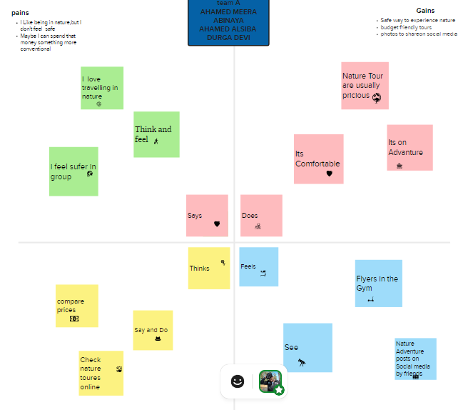

* Ideation & Brainstorming Map

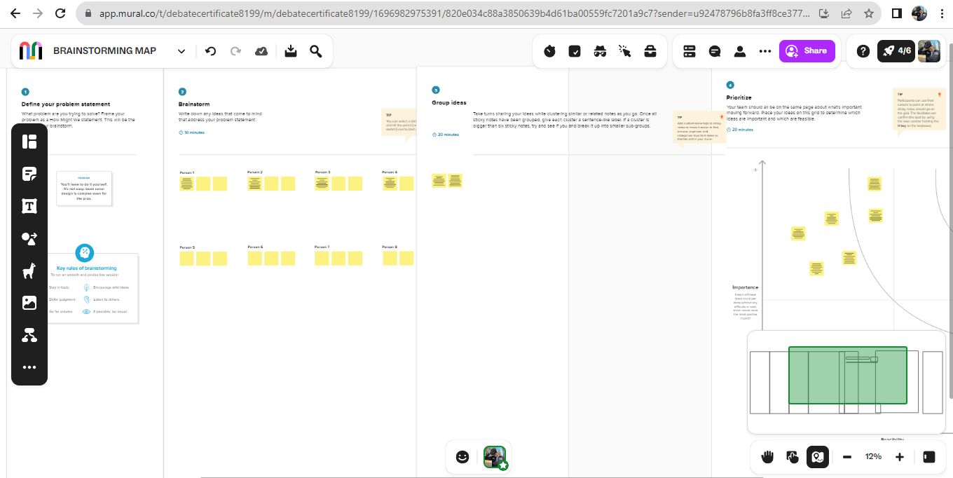

**3.RESULT**



**4.ADVANTAGE& DISADVANTAGES**

* Book cover design simple and unforgettable
* Communicate with “RAW”,’EMOTIONAL’ and ‘REAL’

**5.APPLICATIONS**

* Search designs on canva
* Then select alone girl design and change that colour and font

**6.CONCLUSION**

* These are the things we have done this project.